Database Table Stuctures

VENUE TABLE//

create table Venue(

venue_id int,

venue_name varchar(20),

address varchar(20),

constraint Venue_Venue_id_pk primary key(venue_id));

desc Venue;

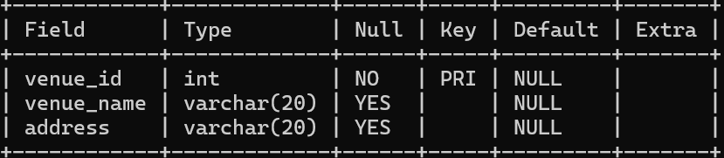

EVENT TABLE//

CREATE TABLE Event (

-> event_id INT PRIMARY KEY,

-> event_name VARCHAR(100),

-> event_date DATE,

-> event_time TIME,

-> venue_id INT,

-> total_seats INT,

-> available_seats INT,

-> ticket_price DECIMAL(10, 2),

-> event_type ENUM('Movie', 'Sports', 'Concert'),

-> booking_id INT,

-> CONSTRAINT Event_venue_id_fk FOREIGN KEY (venue_id) REFERENCES Venue(venue_id),

-> CONSTRAINT Event_booking_id_fk FOREIGN KEY (booking_id) REFERENCES Booking(booking_id)

-> );

Desc Event;

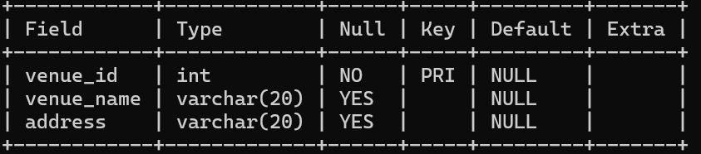

CUSTOMER TABLE//

CREATE TABLE Customer (

-> customer_id INT PRIMARY KEY,

-> customer_name VARCHAR(100),

-> email VARCHAR(100),

-> phone_number VARCHAR(15),

-> booking_id INT,

-> CONSTRAINT Customer_booking_id_fk FOREIGN KEY (booking_id) REFERENCES Booking(booking_id)

-> );

Desc Customer;

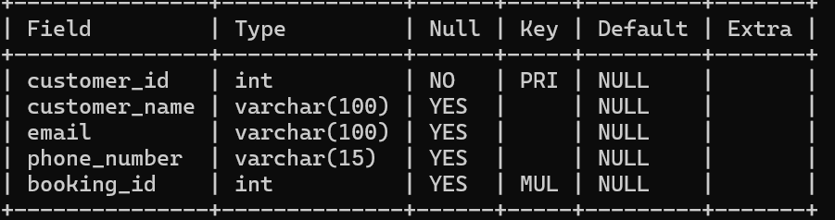

BOOKING TABLE//

CREATE TABLE Booking (

-> booking_id INT PRIMARY KEY,

-> customer_id INT,

-> event_id INT,

-> num_tickets INT,

-> total_cost DECIMAL(10, 2),

-> booking_date DATE,

-> CONSTRAINT Booking_event_id_fk FOREIGN KEY (event_id) REFERENCES Event(event_id)

-> );

desc Booking;

